The Trench  Award 2019  Total Bursary Value: €7,000 | 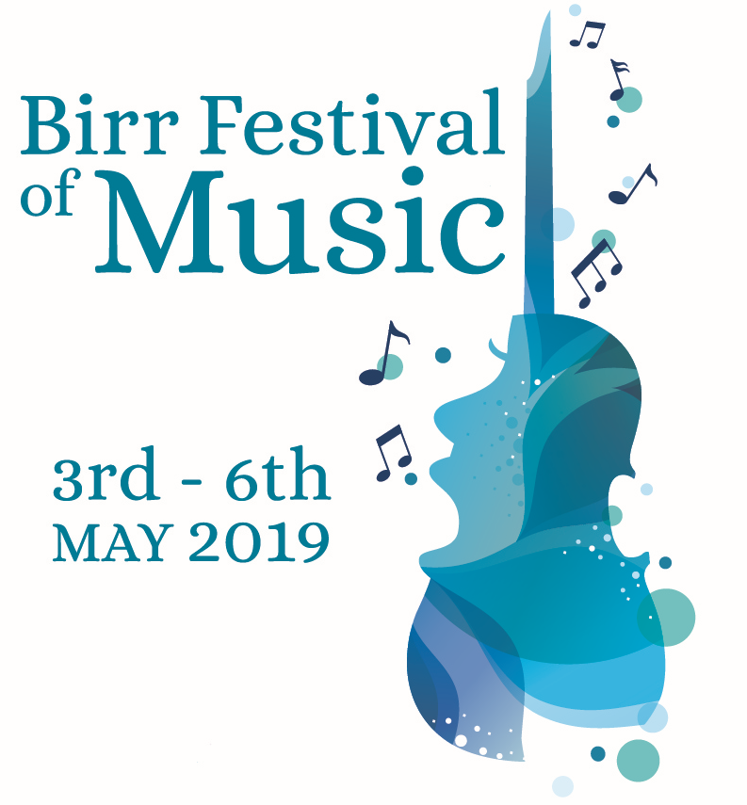

Applications are invited from young singers and musicians who are pursuing a career in professional performance in the classical field.

About the Bursary
Now in its sixth year, The Trench Award aims to assist a young singer or musician develop their professional career through further study at home or abroad. The bursary will be awarded to a student attending, or having been offered a confirmed place at, a University/ Music College or another accredited specialist music establishment undertaking classical music studies, either instrumental or vocal, in pursuit of a career in professional performance.

Six finalists will be invited to attend Birr Festival of Music and to perform a
15 minute programme at Birr Theatre & Arts Centre, Birr, Co. Offaly on Sunday 5 May 2019 when the bursary will be awarded by a prestigious selection panel.

Eligibility
- Applicants must be from the general midlands region and under 27 years on 1 January 2019

Application form and further information available from www.birrtheatre.com
or by request from TheTrenchAward@gmail.com
Deadline for receipt of application is Thursday 21 February 2019

Important Dates:
Thursday 21 February: Application Deadline
Thursday 14 March: Applicants will be notified
Friday 3 – Monday 6 May – Birr Festival of Music & Voice
Sunday 5 May: The Trench Awards Gala Concert
and announcement of bursary recipient(s)

For further information contact: Maureen de Forge 087 2836675 TheTrenchAward@gmail.com

The Trench Award 2019

About Julia & Patrick Trench
The late Julia & Patrick Trench were noted for their musical evenings at Sopwell Hall, Ballingarry in North Tipperary. Patrick played flute, harp and organ, Julia played piano and organ. Music was the bonding glue in Patrick’s marriage with Julia who, even in wartime, travelled weekly to London to enjoy the opera season. When Patrick died, Julia provided funding for the beautiful Trench Harp as one way of commemorating him. The harp was presented to Triona Marshall, from Portlaoise, who performs regularly with the National Concert Orchestra and has toured worldwide with The Chieftans. Julia Trench was one of the many generous benefactors involved in the establishment of Birr Theatre & Arts Centre in the mid-1990s.

Further Information
- Applications are invited from students attending, or having been offered a confirmed place at, a University/ Music College or other accredited specialist music establishment undertaking classical music studies, either instrumental or vocal, in pursuit of a career in professional performance.
- Applicants must be from the general midlands region and under 27 years on 1 January 2019
- Previous bursary recipients may not apply.
- The Trench Award is €3,500. Further bursaries, to the value of €3,500 may be awarded to one or more recipients including the Birr Lions Club Bursary, the Canto al Serchio Prize and the Audience Prize.
- Application forms are available to download on www.birrtheatre.com or by request from TheTrenchAward@gmail.com
- Applicants are requested to complete an Application Form and return it along with a recording (MP3) of two contrasting pieces and a high resolution headshot to TheTrenchAward@gmail.com by Thursday 21 February, 3pm.
- ** Handwritten applications will not be considered
- Successful applicants will be notified by Thursday 14 March 2019. Finalists will perform a
15 minute programme at Birr Theatre & Arts Centre on Sunday 5 May 2019 at 7.30pm.
- Finalists will attend all events at the Birr Festival of Music and participate in masterclasses on Saturday, given by distinguished coaches in their chosen field.
- The 15 minute programme can be of applicant’s choice. (It is recommended that performers include a variety of style and period in their choice of music with consideration for audience enjoyment).
- Successful applicants will have 30 minutes rehearsal time with the official accompanist.
- Successful applicants must provide a copy of all music programme choices by email no later than 4th April.
- Bursary Recipient(s) are required to acknowledge “The Trench Award” in programme biographies and CVs.
The Trench Award 2019
APPLICATION FORM
Full Name:
Date of Birth: |  | Age as at 1 Jan 2019
Address
(While at college):

Address
(Home):

Email Address:

Phone Number:

Instrument /
Voice type:

Name of Course and Year:

Name of Current / Proposed University/Music College/Institution:

Music Educational Details to date to include examinations:
Year | Awarding Body | Results (if available)
(insert more rows if required)

Are you in receipt of any other bursaries, awards or scholarships, please specify:

Professional Engagements (if applicable) – Past and Future:

Name and contact details of referee, eg: Instrumental/Vocal Teacher; Head of Music or Department at University/College/Institute.
Name | Contact Details

Music Programme ~ 15 minutes ~ Please outline proposed choice of repertoire. (Changes may be made at a later stage)

Please state what you hope to achieve through your continued training and why you believe you should be awarded this bursary (max 200 words)

Biography (100-150 words)

Where did you hear about The Trench Award? _________________________

Please submit MP3 recording of two contrasting pieces and a High Resolution Headshot.
*Studio quality recording is NOT required. Please use whatever equipment you have already e.g. phone.

Check List
- Completed application form (.doc or .docx format only)
- High-Res Headshot (must be at least 1MB and 300dpi)
- MP3 recording
Applications should be e-mailed to
TheTrenchAward@gmail.com
Deadline for receipt of application is Thursday 21 February 2019

