The Trench  Award 2020  Total Bursaries: €8,000 | 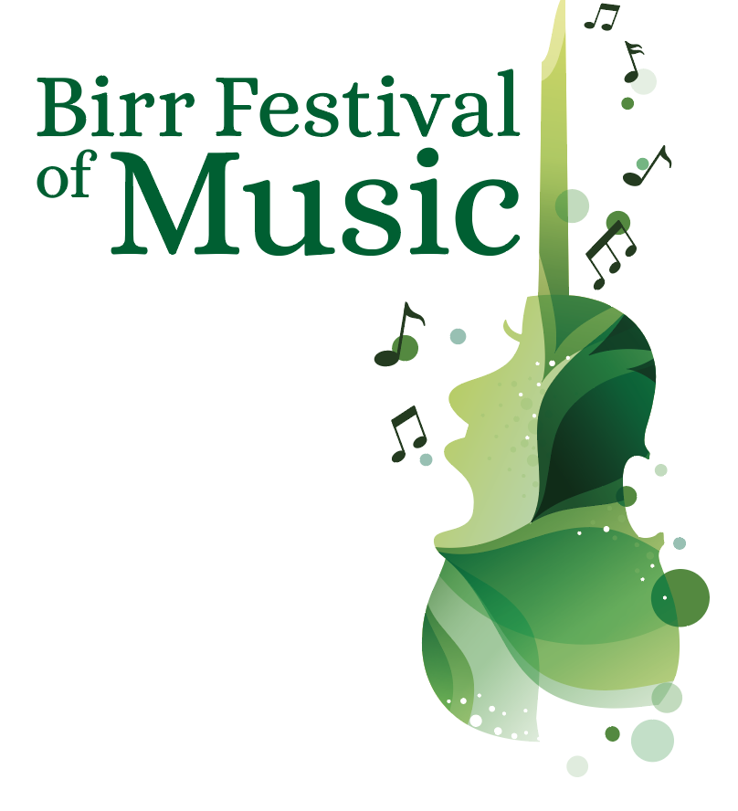  1st – 4th May 2020

Applications are invited from young singers and musicians who are pursuing a career in professional performance in the classical field.

About the Bursary
Now in its seventh year, The Trench Award aims to assist a young singer or musician develop their professional career through further study at home or abroad. The bursary will be awarded to a student attending, or having been offered a confirmed place at, a University/ Music College or another accredited specialist music establishment undertaking classical music studies, either instrumental or vocal, in pursuit of a career in professional performance.

Six finalists will be invited to attend Birr Festival of Music and to perform a
15 minute programme at Birr Theatre & Arts Centre, Birr, Co. Offaly on Sunday 3 May 2020 when the bursaries will be awarded by a prestigious selection panel.

Eligibility
- Applicants must be from the general midlands region and under 27 years on 1 January 2020

Application form and further information available from www.birrtheatre.com
or by request from TheTrenchAward@gmail.com
Deadline for receipt of application is Thursday 27 February 2020

Important Dates:
Thursday 27 February: Application Deadline
Thursday 12 March: Applicants will be notified
Friday 1 – Monday 4 May – Birr Festival of Music
Sunday 3 May: The Trench Awards Gala Concert
and announcement of bursary recipient(s)

For further information contact: Maureen de Forge 087 2836675 TheTrenchAward@gmail.com

The Trench Award 2020

Julia & Patrick Trench
The late Julia & Patrick Trench were noted for their musical evenings at Sopwell Hall, Ballingarry in North Tipperary. Patrick played flute, harp and organ, Julia played piano and organ. Music was the bonding glue in Patrick’s marriage with Julia who, even in wartime, travelled weekly to London to enjoy the opera season. Julia Trench, who died in 2007, designated that the residue of her estate be used to create a Trust Fund to support educational, religious, social and community projects. Thus, the JVM Trench Trust was established and has since been supporting appropriate projects, mainly in the Midlands of Ireland. Julia Trench was one of the many generous benefactors involved in the establishment of Birr Theatre & Arts Centre in the mid-1990s.

Further Information
- The Trench Award is €3,500. Further bursaries, to the value of €3,500 may be awarded to one or more recipients including the Birr Lions Club Bursary, the Canto al Serchio Prize (for voice) and the Audience Prize.
- The Audrey Chisholm Award is a new bursary (for instrument) in memory of the late Audrey Chisholm to the value of €1,000, which is funded by Audrey's brother, Danvers, from her estate. As Audrey's father, William, was the forester at Birr Castle, she grew up on Oxmantown Mall, Birr. Her mother, Ciss, taught piano and gave Audrey her first lessons before she moved to Patricia Read and Rhona Marshall. Audrey combined a career as a concert pianist and hugely popular and successful teacher at the Royal Irish Academy of Music in Dublin.
- Applications are invited from students attending, or having been offered a confirmed place at, a University/ Music College or other accredited specialist music establishment undertaking classical music studies, either instrumental or vocal, in pursuit of a career in professional performance.
- Applicants must be from the general midlands region and under 27 years on 1 January 2020
- Previous bursary recipients may not apply.
- Application forms are available to download on www.birrtheatre.com or by request from TheTrenchAward@gmail.com
- Applicants are requested to complete an Application Form and return it along with a recording (MP3) of two contrasting pieces and a high resolution headshot to TheTrenchAward@gmail.com by Thursday 27 February, 3pm.
- ** Handwritten applications will not be considered
- Successful applicants will be notified by Thursday 12 March 2020. Finalists will perform a 15 minute programme at Birr Theatre & Arts Centre on Sunday 3 May 2020 at 7.30pm.
- Finalists will attend all events at the Birr Festival of Music and participate in masterclasses on Saturday and Monday, given by distinguished coaches in their chosen field.
- The 15 minute programme can be of applicant’s choice. (It is recommended that performers include a variety of style and period in their choice of music with consideration for audience enjoyment).
- Successful applicants will have 30 minutes rehearsal time with the official accompanist.
- Successful applicants must provide a copy of all music programme choices by email no later than 2nd April.
- Bursary Recipient(s) are required to acknowledge “The Trench Award” in programme biographies and CVs.
The Trench Award 2020
APPLICATION FORM
Full Name:
Date of Birth: |  | Age as at 1 Jan 2020
Address
(While at college):

Address
(Home):

Email Address:

Phone Number:

Instrument /
Voice type:

Name of Course and Year:

Name of Current / Proposed University/Music College/Institution:

Music Educational Details to date to include examinations:
Year | Awarding Body | Results (if available)
(insert more rows if required)

Are you in receipt of any other bursaries, awards or scholarships, please specify:

Professional Engagements (if applicable) – Past and Future:

Name and contact details of referee, eg: Instrumental/Vocal Teacher; Head of Music or Department at University/College/Institute.
Name | Contact Details

Music Programme ~ 15 minutes ~ Please outline proposed choice of repertoire. (Changes may be made at a later stage)

Please state what you hope to achieve through your continued training and why you believe you should be awarded this bursary (max 200 words)

Biography (100-150 words)

Where did you hear about The Trench Award? _________________________

Please submit MP3 recording of two contrasting pieces and a High Resolution Headshot.
*Studio quality recording is NOT required. Please use whatever equipment you have already e.g. phone.

Check List
- Completed application form (.doc or .docx format only)
- High-Res Headshot (must be at least 1MB and 300dpi)
- MP3 recording
Applications should be e-mailed to
TheTrenchAward@gmail.com
Deadline for receipt of application is Thursday 27 February 2020

